PWA Video 30 Testing in emulator

<https://www.youtube.com/watch?v=sI7EdkYiU20>

Hosting URL: <https://food-app-pwa-4ea73.web.app>

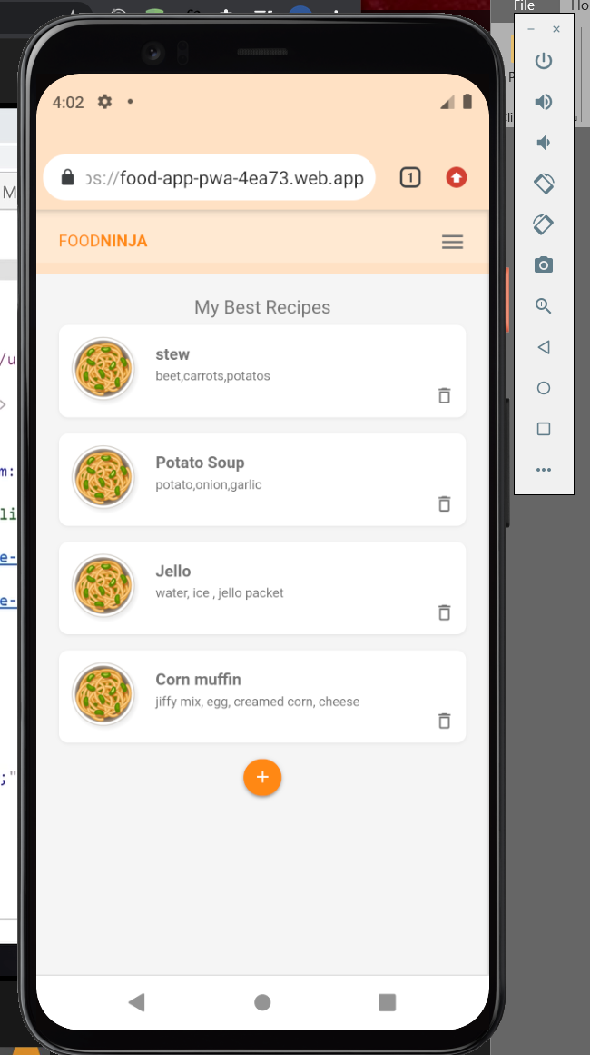

PWA 31- Next steps

